**Hive Box courier delivery process**

**Company Profile: <https://fcbox.com/pages/product/introduce.html>**

**Fengchao Express Delivery System is a unified online management system customized by Fengchao Technology for enterprises, industrial park management offices, community property management offices, etc. It provides a common delivery solution of cabinet + point + person to solve single delivery. The high labor cost of collection management.**

1. **Fengchao Technology Company invented the delivery cabinet, and they built the delivery cabinet and remote control system by themselves. Registered delivery personnel use the delivery counter for free during the promotion period. Due to lack of resources, only the y mobile platform can be used to send SMS notifications to customers.**

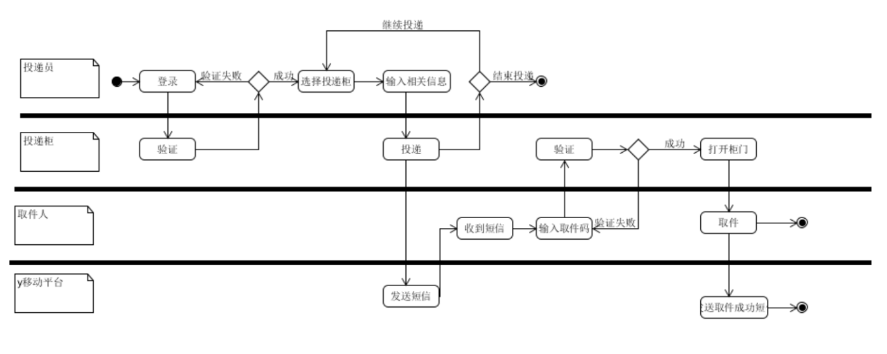

1. **With the promotion of the product, company x reached an agreement with major express delivery companies. Company x has added a QR code scanning device to the courier cabinet. Couriers of company z can not only log in on the courier cabinet (authentication service provided by company z), but also scan the courier number, and send text messages to company z automatically after delivery to the cabinet To customers. After the customer picks up the package, it will be automatically sent to z company for delivery.**

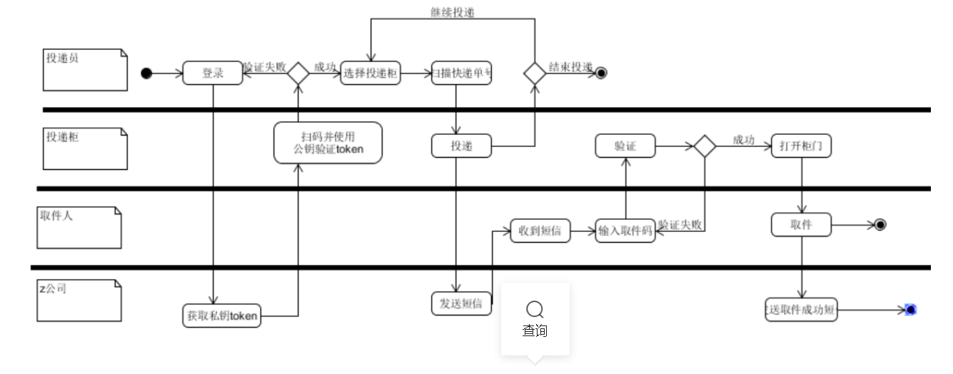

1. **Company x further optimized its services and developed a WeChat applet to scan QR codes to get express delivery. If the user has followed the company's official account, he will directly push the user's pickup code and other information through the official account. No more text messages**

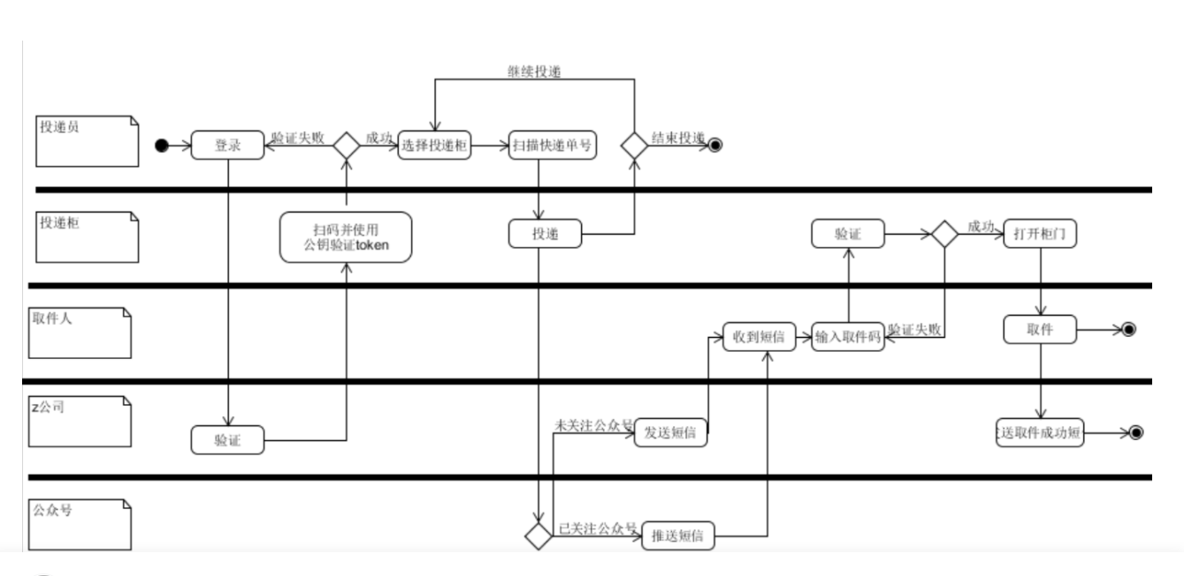

**According to the above process, the final use case diagram model of the express cabinet system is given**

**Use normal colors to indicate the use cases reflected in the first business process**

**Use a green background to describe the use cases added or modified in the second business scenario, and support for Actor**

**Use a yellow background to describe the use cases added or modified in the third business scenario, and support for Actor**

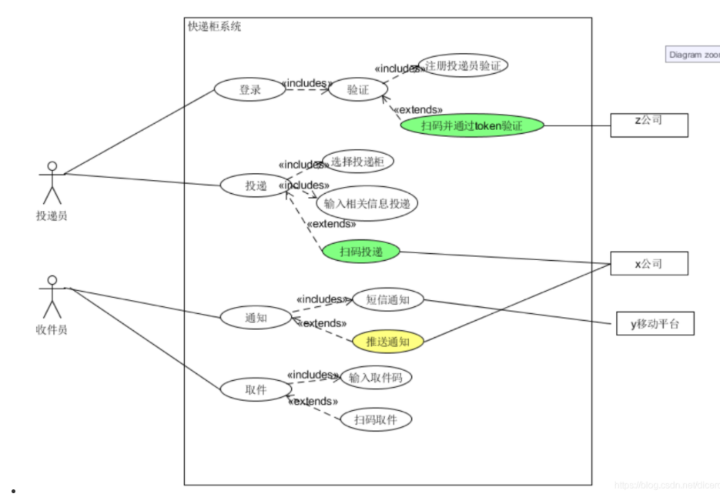

**Future State Process Benefits：**

